Volunteer Recruitment Packet
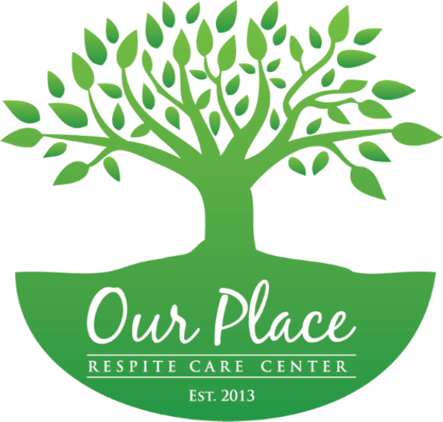

The Alzheimer’s Alliance Tri-State Area is a volunteer based organization and we are always looking to add new members to our outstanding team!
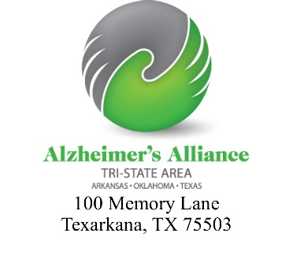

The Alzheimer’s Alliance Tri-State Area is a 50l(c)3 Non-profit organization
100% of all proceeds stay local and benefit the families in our community that desperately need the services and resources that we provide.
Volunteer Responsibilities at Our Place Day Respite Center

Our Place Day Respite Center, a program of the Alzheimer’s Alliance Tri-State Area, provides rest for the caregivers of those diagnosed with Alzheimer’s disease and related dementias. Twice a week, caregivers bring their loved ones to Our Place from 9 A.M. – 3 P.M. and we enjoy a multitude of activities throughout our day.
We strive to maintain dignity at all times with those who come to visit our facility, so we refer to them as our “Friends” rather than patients. Our “Companions” are those volunteers who help at Our Place. We make the distinction between Friends and Companions through our names tags, our Friends names are typed in BLUE while our Companions are typed in RED. This allows us all to blend, but for our newer volunteers and visitors it offers a distinction.
We take pride in our one Friend to one Companion ratio. This allows us to fully meet the needs and wishes of our Friends while also allowing us to keep a tight watch on them throughout the day. Each morning, Companions should review their Friends notebook to familiarize themselves with any changes or noted behavior. At the end of the day, Companions are expected to log all details of their Friend’s day. These notebooks are used by the staff to show caregivers how their loved one has reacted to Our Place Respite Care.

We have no age requirement to volunteer!!
We invite both the young (at least 18) and the young at heart to be companions. You are not required to do any heavy lifting.
Volunteers are only expected to act as Companions to our Friends. Throughout the day our Companions spend time assisting our Friends when needed (needs vary with each friend and usually can be found in the Friend’s notebook), they engage in fun conversation and act as partners in the many games and activities we have here at Our Place Day Respite Center.

Our daily activities include
•A light breakfast
•Activity – light exercises
•Fun in the cushy area – usually consisting of games like catchphrase, or fun facts, crazy state laws etc.
•Lunch
•Bingo in the Kitchen (other games like dominoes and can change with interest of Friends)
•Crafts
•Story Time
•Live entertainment – (occasionally entertainment from our own Companions)
•Light snack
•Brief volunteer meeting at the end of the day

This is a tentative list of activities and is subject to change on a daily basis. There is a daily schedule located on the refrigerator in the respite kitchen and by the Our Place entrance that is more detailed.
Some Friends will not want, or in some cases won’t be able, to participate in every event of the day. In these situations, we like to take them aside and do something they like to do, one on one. For instance, if one of our Friends does not like Bingo we may take them on a walk around the facility, share one of our reminiscing books, or sit in the couch area and talk or rest.
Lunch is provided by Senior Support Services each day.
Our Place has live entertainment each day of respite. Many local groups volunteer their time and talent to entertain our Friends and on special occasions, our Companions will showcase their talents! Typically, our local talent will perform songs that get our Friends up and dancing! Not only is this great exercise for our Friends, it also provides great socialization.

Why should you volunteer?
There are many benefits of volunteering. Not only does the community and organization benefit from your selfless decision to dedicate your time, but so do you! According to multiple studies conducted across the United States and Canada, volunteering can be beneficial to your health, your life expectancy as well as your employment status!
- The Bureau of Labor Statistics found that 62.6 Million people volunteered either through or for an organization between September 2014 and September 2015.
- 76% of people who volunteered in the last 12 months say that volunteering made them feel healthier.
- 94% of people who volunteered in the 12 months say that volunteering improves their mood.
- 78% of people who volunteered in the last 12 months say that volunteering lowers their stress levels.
- 96% say that volunteering enriches their sense of purpose in life.
- Volunteering at Our Place can generate a good recommendation or reference for students or workers.
If you are interested in becoming a Companion to our Friends at Our Place, or want to come in for a “volunteer trail day” or want more information please contact us at 903.223.8021
REMEMBER- When ACTION meets Compassion– lives change
Thank you for considering sharing your time with us at Our Place.
If you have any questions or want additional information please contact us at 903.223.8021,
by email at samantha@alztristate.org , on our website www.alztristate.org
or visit our facility located at
100 Memory Lane, Texarkana, TX 75503

